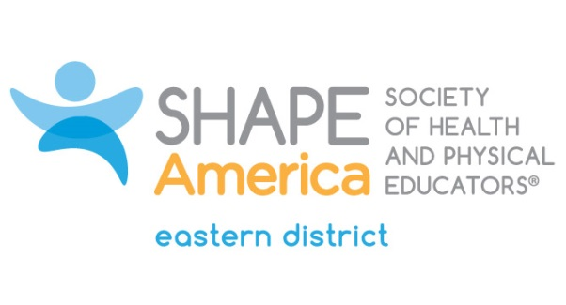

2019 Candidate for the Office of Member-at-Large

Name: Marybeth H. Fede
School/Org: Southern CT State University

Bio (300 Words or Less):
I’m a professor at Southern Connecticut State University in Physical Education Teacher Education, and a full-time faculty member at SCSU for 20 years. I have my Ed.D in Adult Education, specializing in interdisciplinary physically active course models, from Nova Southeastern University (09), Sixth year in School Health (SCSU, 87), MS in Human Performance, (SCSU, 86) and a BS in Physical Education (SCSU, 79). Nationally, I served as a proxy at the Society of Association Managers, SAM Leadership conference in Wisconsin for Connecticut Director, Connie Kapral. Regionally, I served on the Eastern District Leadership Council, on the Advocacy and Communications Committee, Nominating Committee and the Conference planning Committee. Locally, I have been on the Board of Directors and secretary of the Alumni Association (SCSU) and presently serve in a voluntary capacity. I serve CTAHPERD, as the assistant conference program coordinator, and have served as VP of Physical Education. As a member of SHAPE America, I have presented nationally and internationally on PASS, physically active school systems, based on CSPAP and is Connecticut’s framework for comprehensive physically active school systems. I am the co-author of PASS: A Guidebook for Creating Physically Active School Systems (2015), a Shape America webinar (2015), and several articles in peer reviewed journals, such as JOPERD, from 2012-present, with a special feature article on CSPAP and Higher Education, (2016). I presented CSPAP/PASS at PETE/HETE (Oct.2018), and in Tokyo Japan, Aging & Society: 8th Interdisciplinary conference, The Effects of Physically Active Lifestyles on Cognition & Aging: Benefits to Mind & Body (Sept. 2018). Physically Active Lifestyles for Seniors (PALS) is the next initiative for Connecticut.

What leadership qualities will you bring to the Eastern District Leadership Council?

I am a passionate person and I love getting things done! I am not afraid to pitch new ideas and more importantly, do the work to follow them through to fruition. I am a people person and a worker “bee”. I never ask anything of anybody that I would not do myself. I am honest and trustworthy and care a great about SHAPE America, the Eastern District, and my State organization, CTAHPERD. More importantly I care about the future of these organizations and try to get our students involved by helping anyway I can, for example helping to organize our student leadership conference in CT. and the College Olympics at Easter District to name a few. Our students are our future and I would like to continue to grow our professional organizations.

